* *Querys*

1). List the employee num ,employ name ,salary ,daily salary of all employee.

* 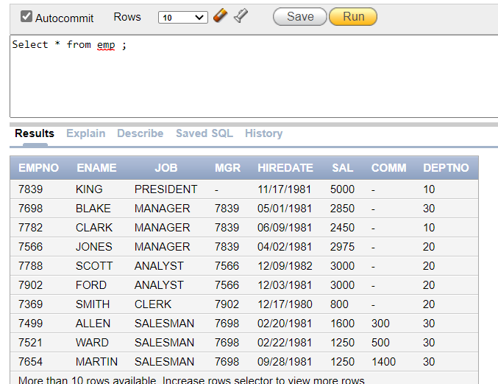select * from emp ;

2). List all the details of employee King.

* 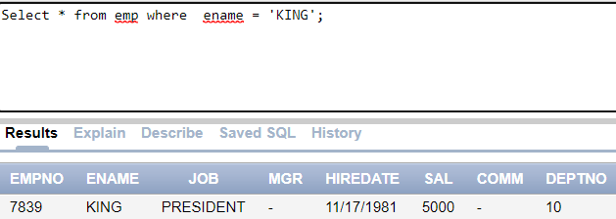Select * from emp where ename=’KING’;

3). List all details of employee whose department number is 10.

* 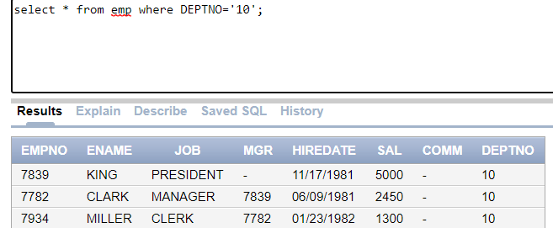select * from emp where DEPTNO='10';

4). List salary of employee whose department no is 20.

* Select sal from emp where deptno='20';

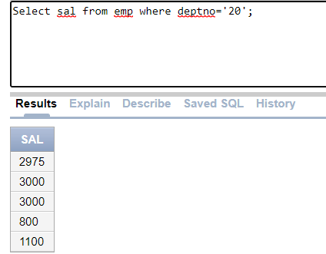

5).List all details of employee whose salary is grater than 2000.

* Select * from emp where sal>2000

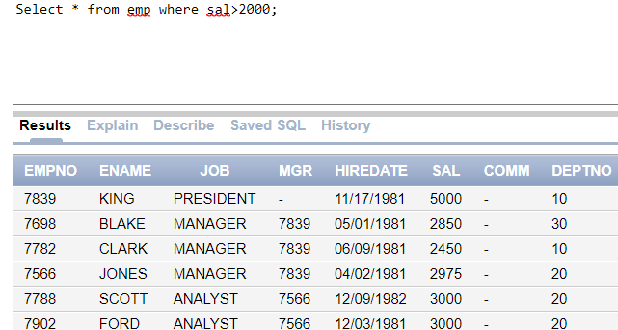6). List the employee name who is working as clerk.

* 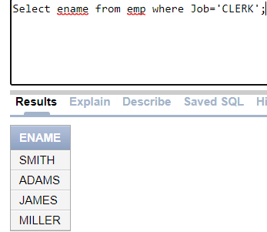Select ename from emp where Job=’CLERK’;

7) List employee name whose job is manager or analyst.

* 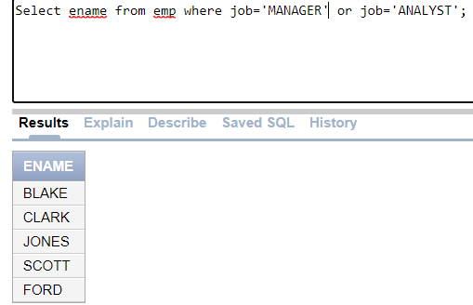Select ename from emp where job=’MANAGER’ or job=’ANALYST’;

8) List all the details of employee whose manager id is 7566.

* 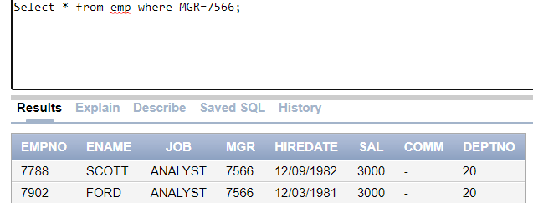Select * from emp where MGR=7566;

9) List all employee details whose salary is grater than 1000 and less than 2000.

* 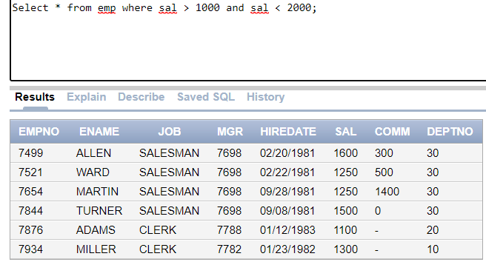Select * from emp where sal > 1000 and sal < 2000;

10) List all employee whose department number is 10 and 20.

* 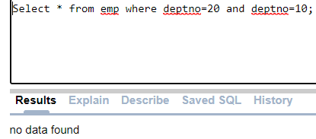Select * from emp where deptno=20 and deptno=10;

11) List the employee name whose hire-date is 12/03/1981 or 09/08/1981

* 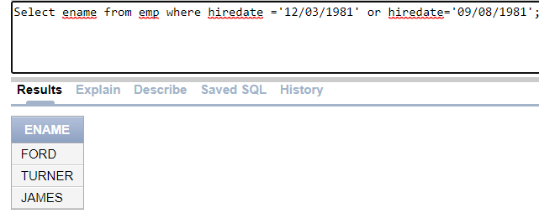 Select ename from emp where hiredate ='12/03/1981' or hiredate='09/08/1981';

12) List employee name whose commission grater than 500.

* Select ENAME from emp where COMM > 500;

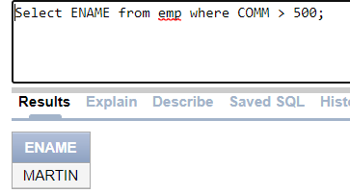

13. Find out the names of all clients.

* 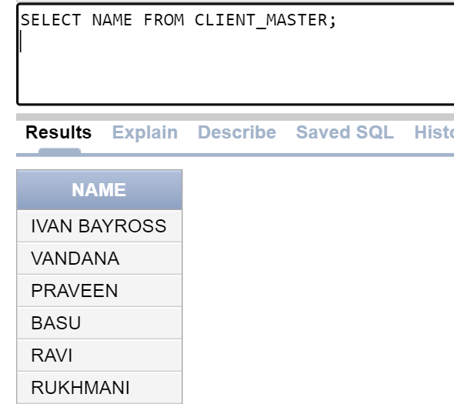SELECT NAME FROM CLIENT_MASTER;

. Retrieve the entire contents of Client_Master table.

* SELECT * FROM CLIENT_MASTER;

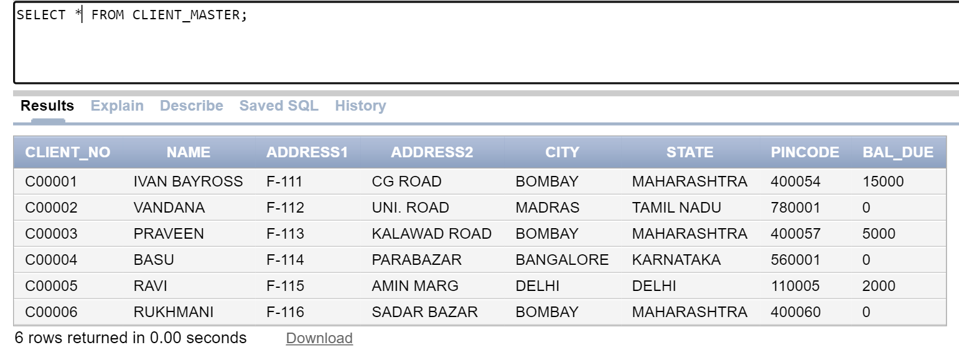

14. Retrieve the names, city and state of all the clients.

* 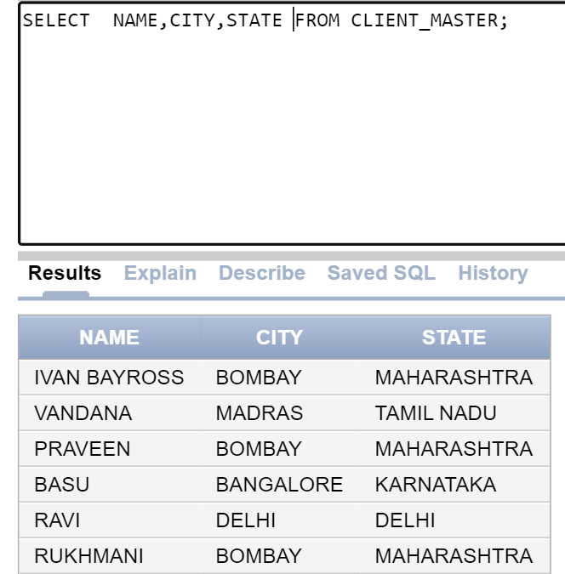SELECT NAME,CITY,STATE FROM CLIENT_MASTER;

15. Print the structure of Client_Master table.

* 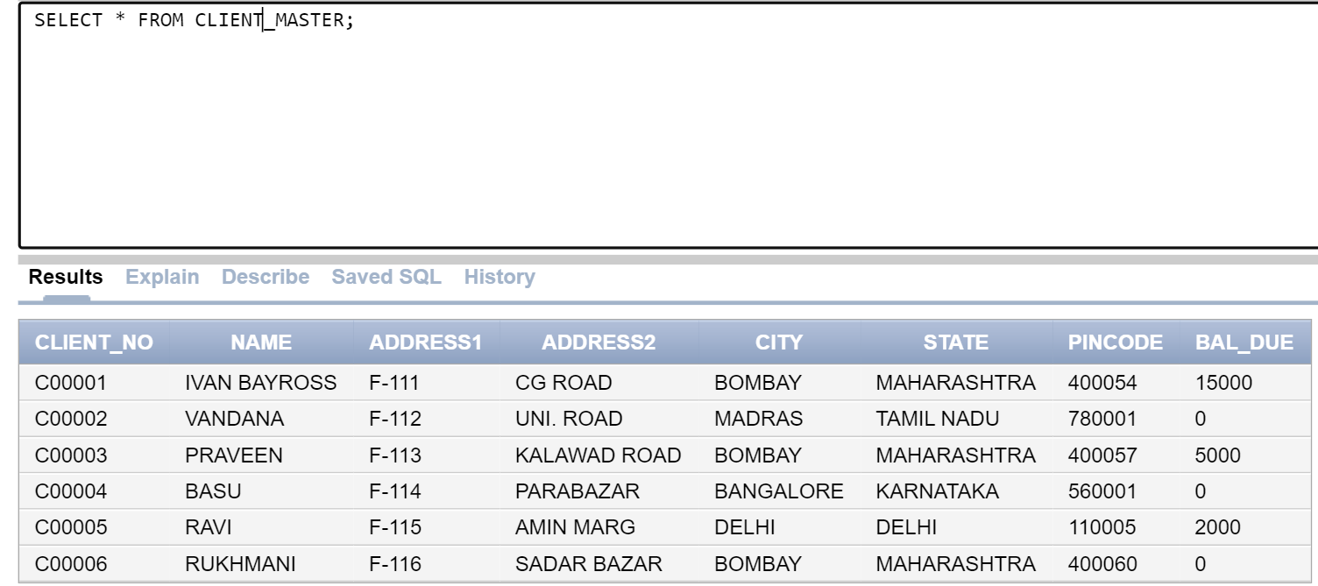SELECT * FROM CLIENT_MASTER;

16. List all the clients who stay in Bombay.

* 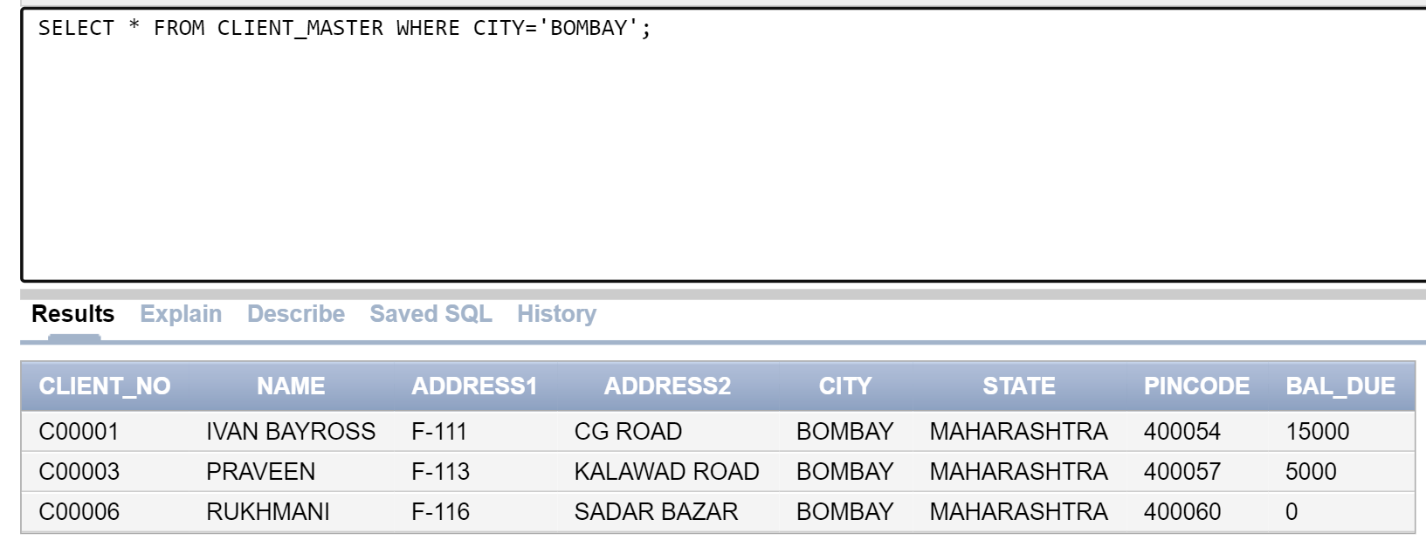SELECT * FROM CLIENT_MASTER WHERE CITY='BOMBAY';

17. List all the clients who are located in Madras.

* 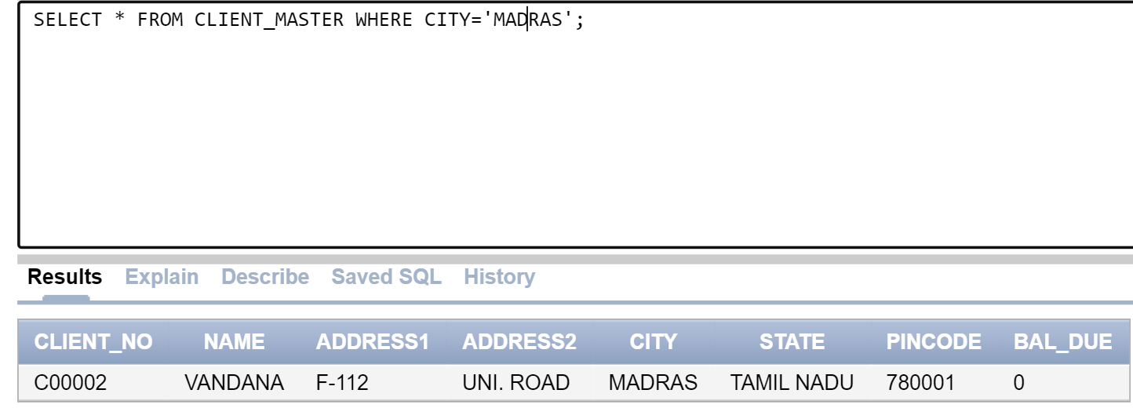SELECT * FROM CLIENT_MASTER WHERE CITY='MADRAS';

12). List the names, city and state of clients who are not in the state of ‘Maharashtra’.

* 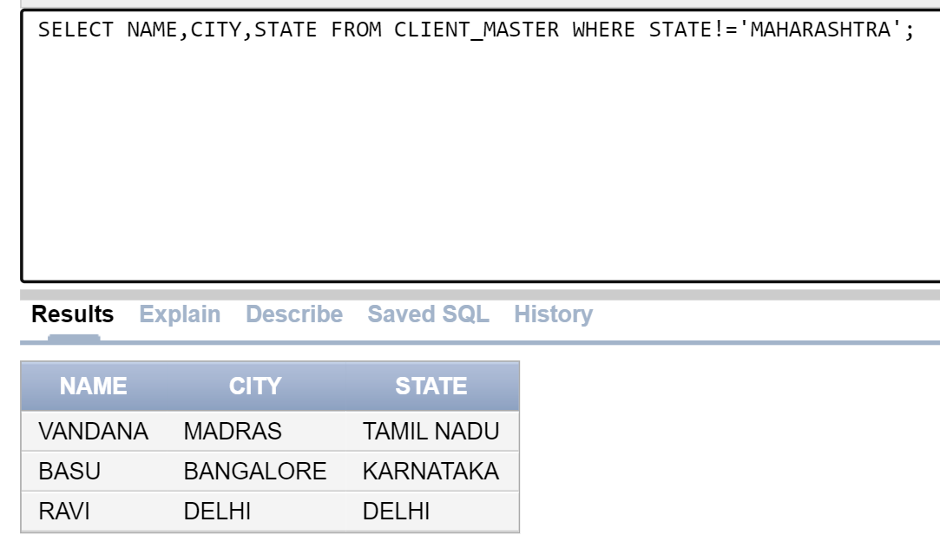SELECT NAME,CITY,STATE FROM CLIENT_MASTER WHERE STATE!='MAHARASHTRA';

13). DISPLAY INFORMATION FOR CLIENT NO C00001.

* SELECT * FROM CLIENT_MASTER WHERE CLIENT_NO='C00001'

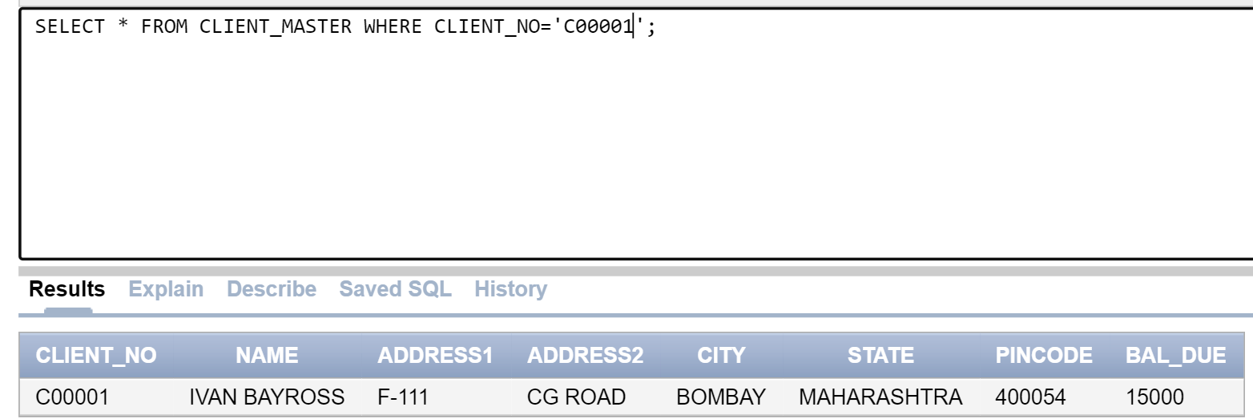

14. LIST THE VARIOUS PRODUCT AVAILABLE FROM THE PRODUCT_MASTER TABLE.

* SELECT DESCRIPTION FROM PRODUCT_MASTER ;

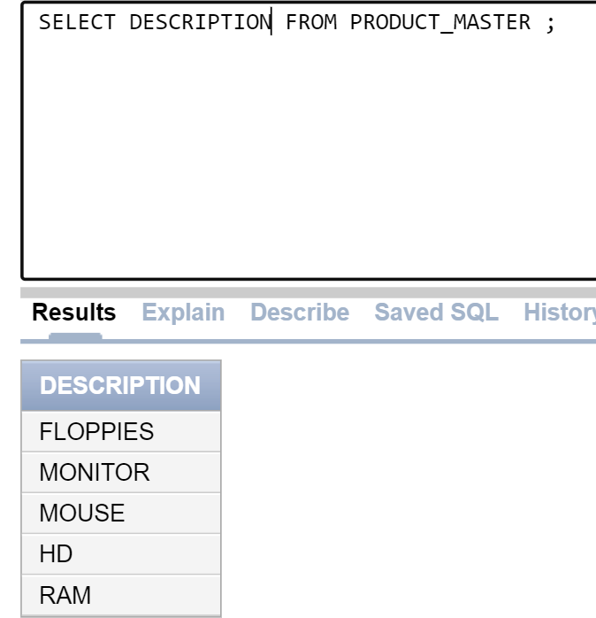

15. FIND ALL THE PRODUCTS WHERE SELLING PRICE IS GREATER THAN RS. 5000.

* 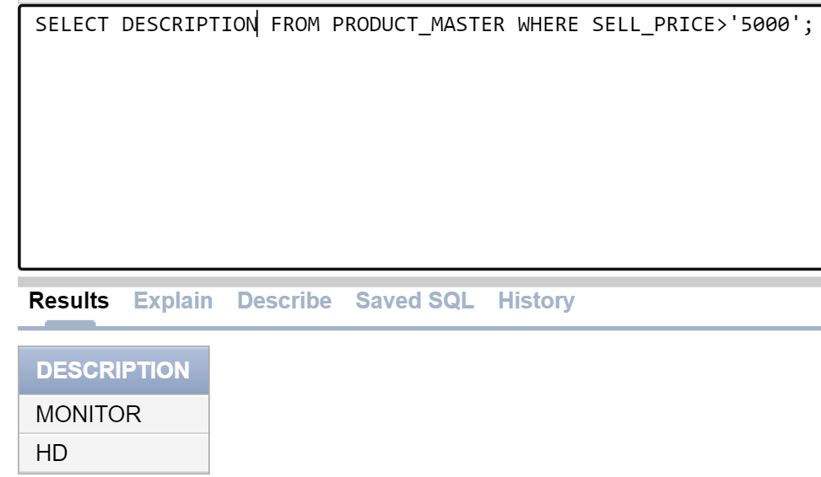SELECT DESCRIPTION FROM PRODUCT_MASTER WHERE SELL_PRICE>'5000';

1.Delete all rows from client_master table.

* 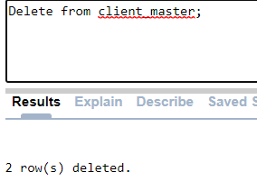Delete from client_master

2.Delete rows from table client_master where the values in the bal_due field is less than 500.

* delete from client_master where bal_due<500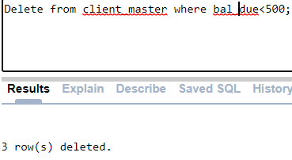;

3.DELETE THE RECORD WITH CLIENT 0001 FROM THE CLIENT MASTER.

* 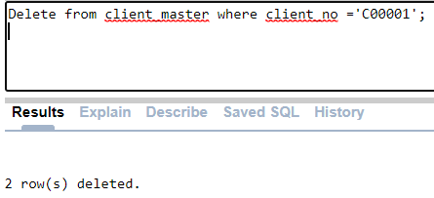Delete from client_master where client_no =’C00001’;

4. Update table client_master change the content of the field name to ‘Vijay kadam’ and the content of the field address1 to ‘SCT JAY APARTMENT’ for the record identified by client_no containg value ‘C00002’.

* 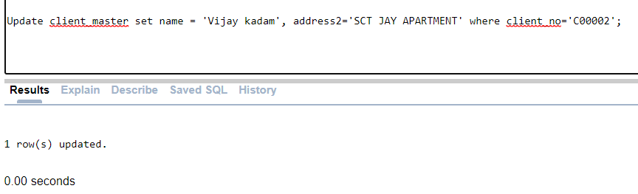Update client_master set name = ‘Vijay kadam’, address2=‘SCT JAY APARTMENT’ where client_no=’C00002’;

5. CHANGE THE SELLING PRICE OF FLOPPY TO 1150

* 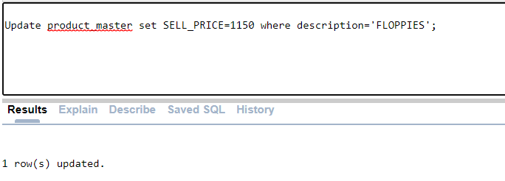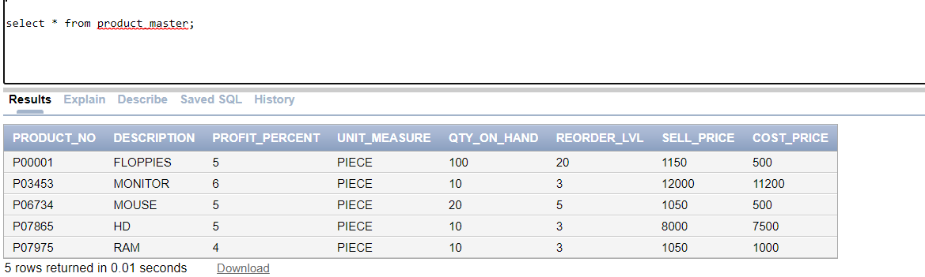Update product_master set sell_price=1150 where description=’Floppies’;

6. CHANGE THE STATE OF CLIENT_NO C00005 TO MAHARASHTRA.

* Update client_master set state=’Maharashtra’ where client_no=’C00005’;

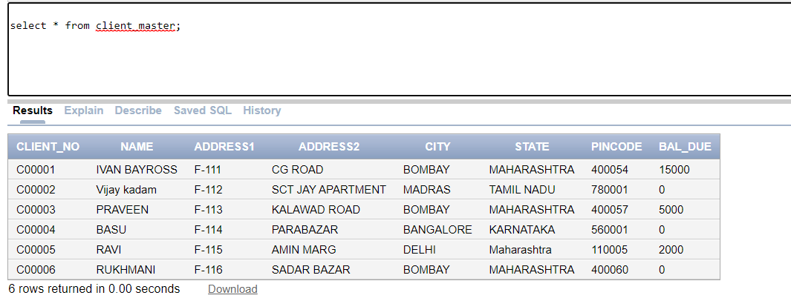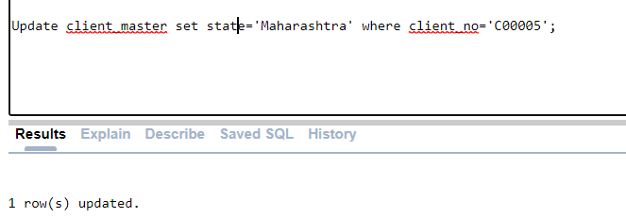

7. CHANGE THE BAL_DUE OF CLIENT_NO C00001 TO 1000.

* 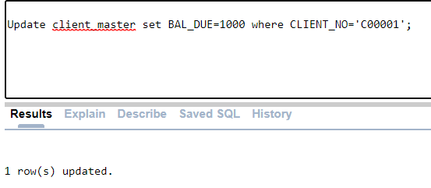Update client_master set bal_due=1000 where client_no=’C00001’;

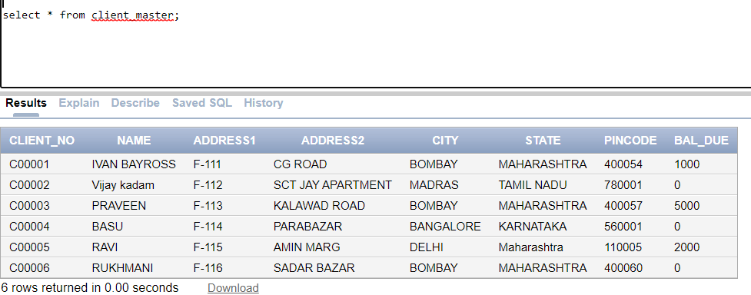

8. Add field’s client_tel, which is a field that can hold a number upto 8 didgits in length and client_fax , which can hold number upto 15 digit in length.

* Alter table client_master add (client_tel number(8), client_fax number(15));

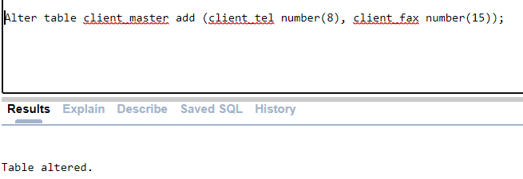

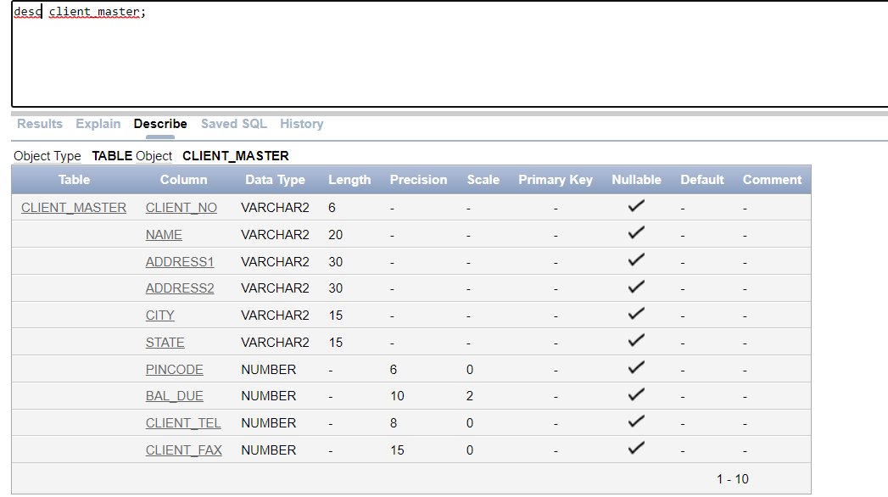

9. Modify the field client_fax of the table client_master to now hold maximum of 25 character values.

* 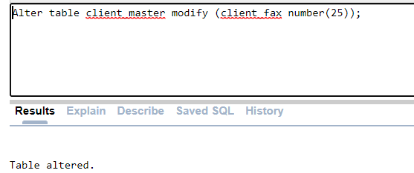Alter table client_master modify (client_fax number(25));

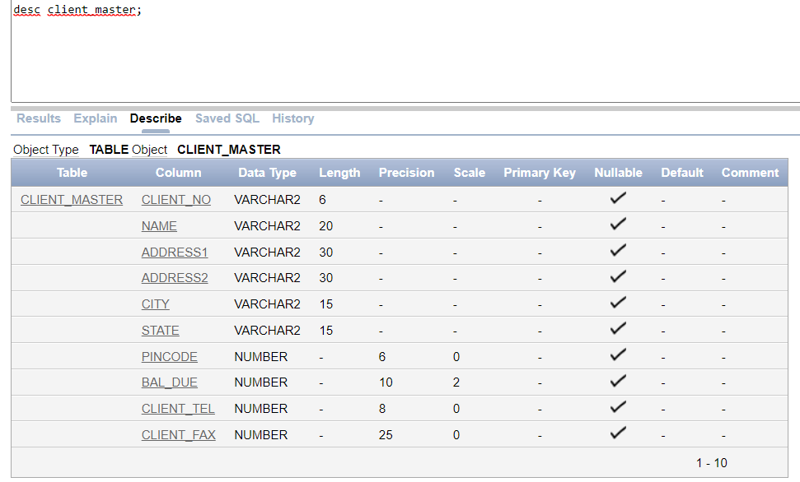

10. Rename table client_master by new name as client_master1

* 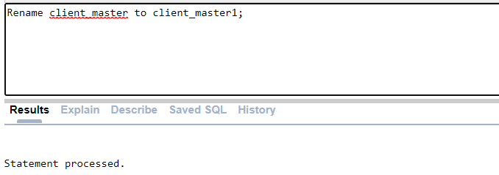Rename client_master to client_master1;

1).Find the Product whose sellingprice>2000and less than or equal to 8000

* 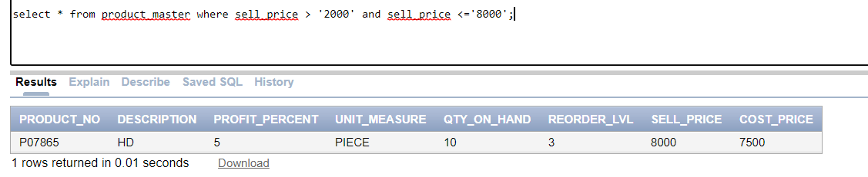Select * fom product_master where sell_price>2000 and sell_price<=8000;

2).DISPLAY INFORMATION FOR CLIENT NO C00001 AND C00002.

* 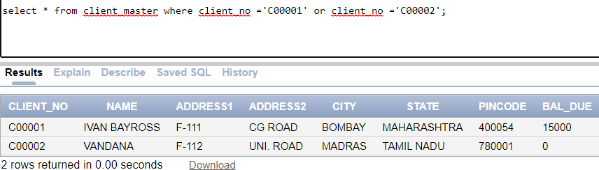Select * from client_master where clien_no = ‘C00001’ or client_no = ‘C00002’;

3).List all the clients who stay in ‘Bombay’ or ‘Delhi’.

* 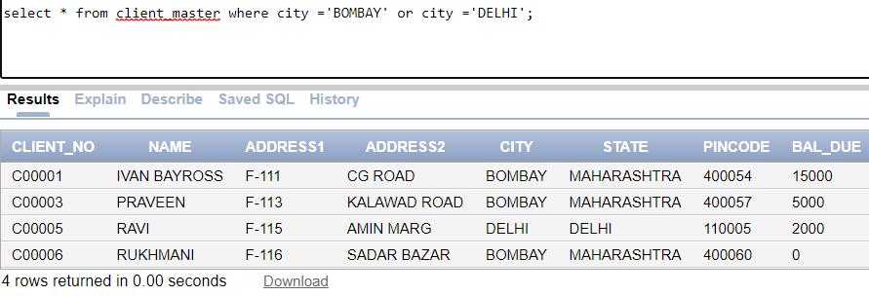Select * from client_master where city = ‘BOMBAY’ and city = ‘DELHI’;

4).List the emps whose Daily Sal is more than 100

* 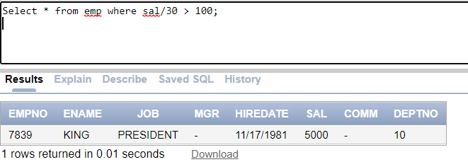Select * from emp where sal/30 > 100;

5).List the emps who joined on 1-MAY-81,3-DEC-81,17-DEC-81,19-JAN-80

* 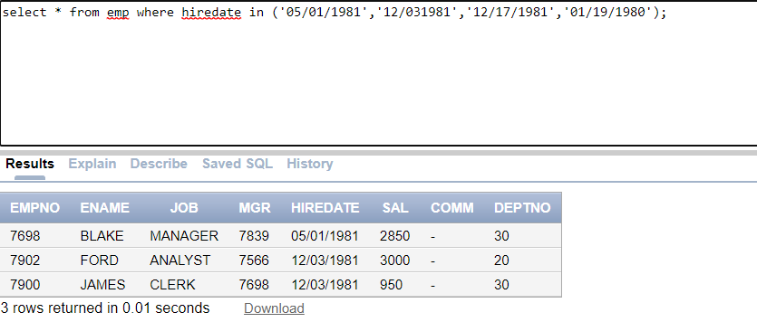Select * from emp where hiredate IN (‘05/01/1981’,’12/03/1981’,’12/17/1981’,’01/19/1980’);

6).List the emps Who Annual sal ranging from 22000 and 45000.

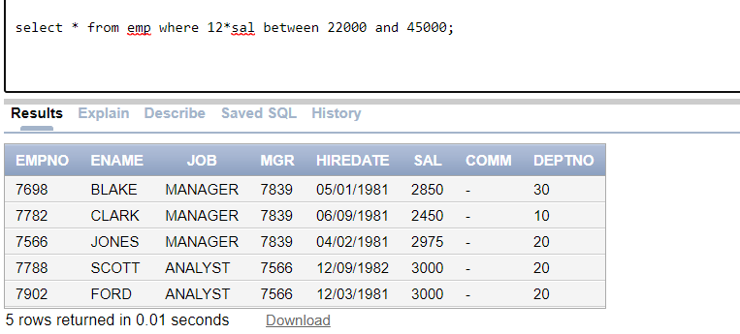Select * from emp where 12*sal between 22000 and 45000;

7).List the Enames those are starting with ‘S’ and with five characters

* Select ename from emp where ename like ‘S%’ and length(ename)=5;

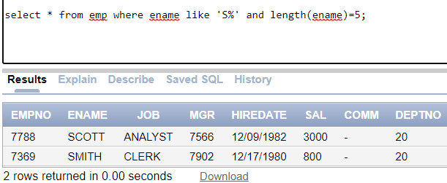

8).List the emps those are having four chars and third character must be ‘r’.

* 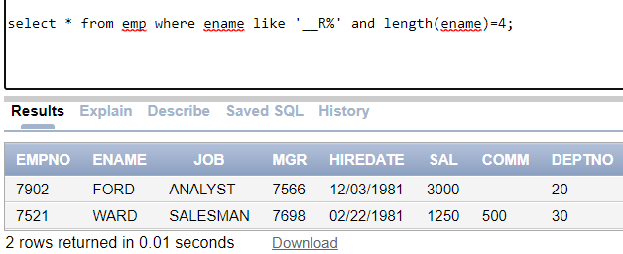Select * from emp where ename like ‘__R%’ and length(ename) = 4;

9).List the Five character names starting with ‘S’ and ending with ‘H’.

* 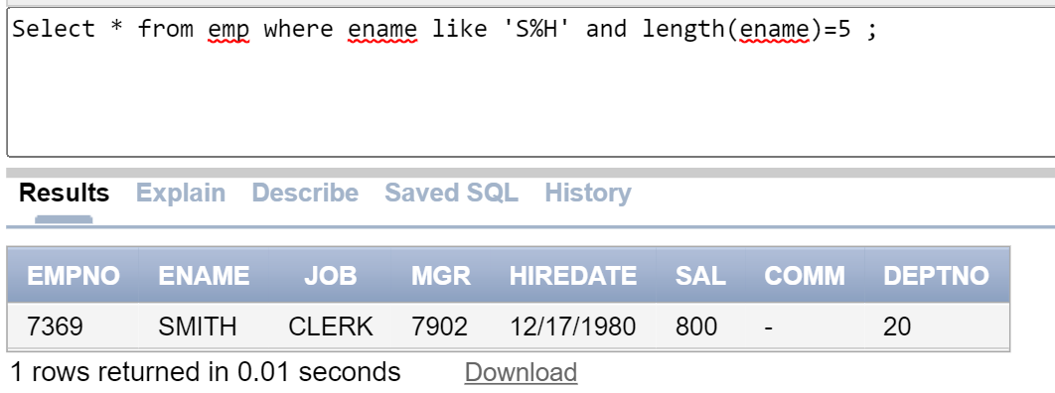Select * from emp where ename like 'S%H' and length(ename)=5 ;

10).List the emps whose Sal is four digit number ending with Zero.

* 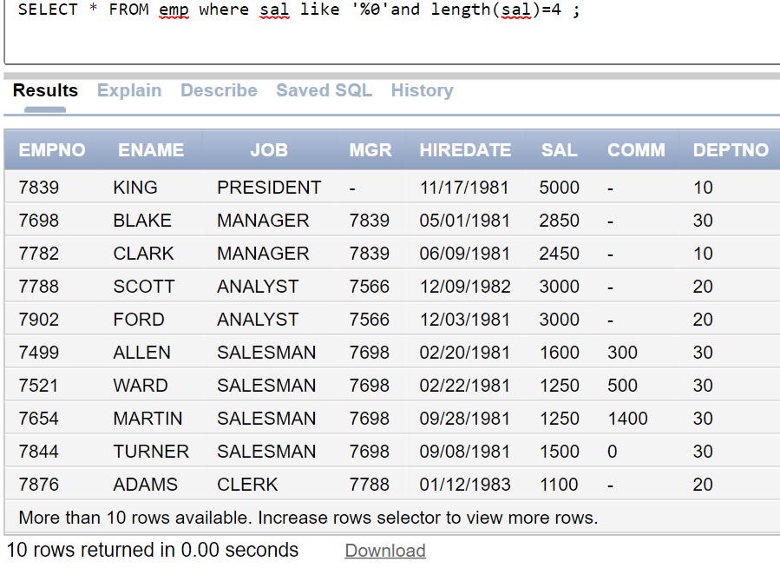Select * from emp where sal like ‘%0’ and length(sal)=4

11).List the emps whose names having a character set ‘LL together.

* Select * from emp where ename like ‘%LL%’;

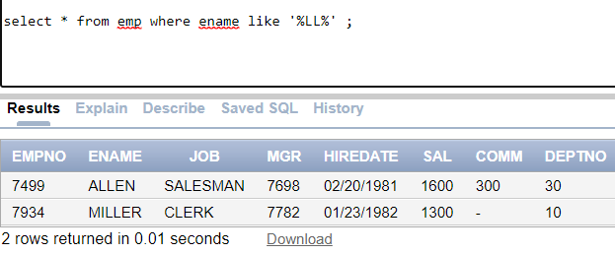

12).List the emps who does not belong to Deptno 20

* Select * from emp where deptno not in (20);

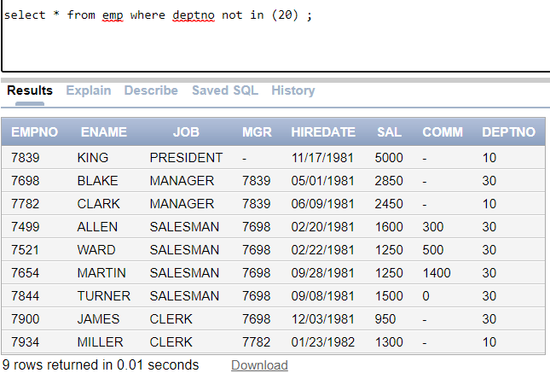

13).List the emps whose Empno not starting with digit 78

* Select * from em where empno not like ‘78%’;

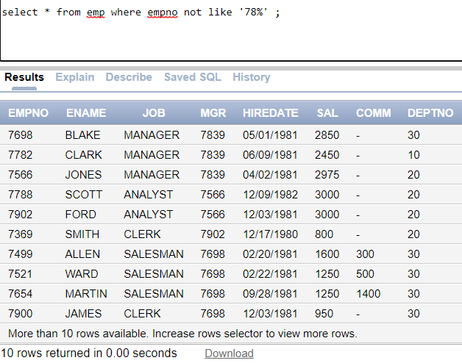

14).List employess who are Analyst and their name contains 'R'

* Select * from emp where job=’ANALYST’ and ename like ‘%R%’;

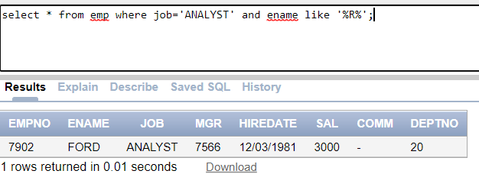

15).list all ks except department no 10

* 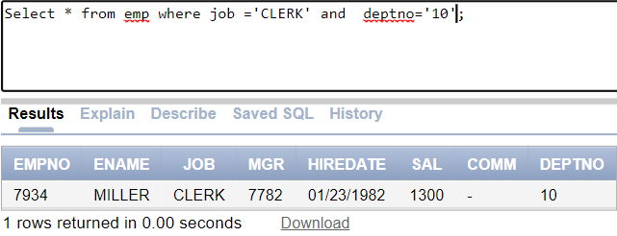Select * from emp where job =’CLERK’ and deptno=’10’;

16).dual table and sysdate operation (16 to 18)

* Select * from dual;

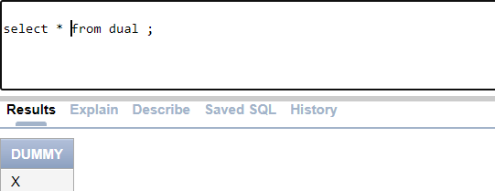

17).

select 2*3 mul from dual

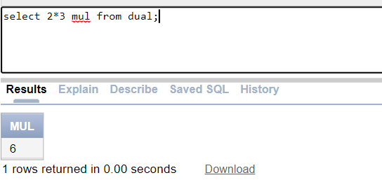

18).

* 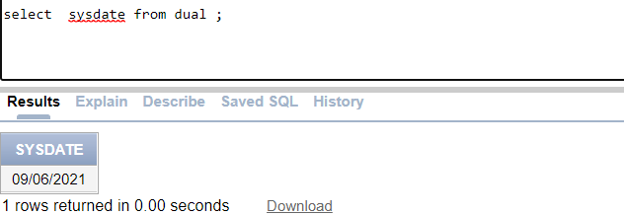select sysdate from dual;

19).List the names of all clients having ‘a’ as the second letter in their names.

* Select ename from client_master1 where name like ‘_A%’;

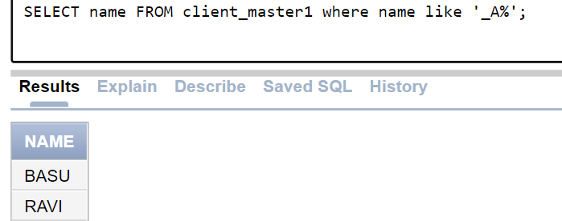

20).List the clients who stay in a city whose first letter is ‘M’.

* 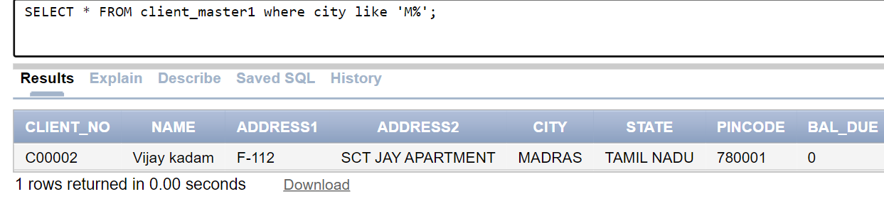Select * from client_master where state like ‘M%’;

21).List all clients whose BalDue is greater than 10000.

* 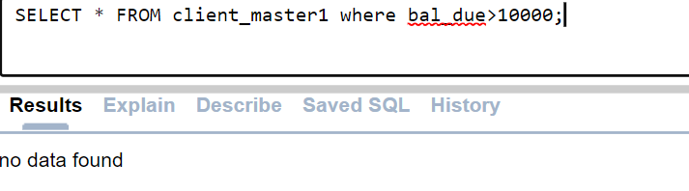Select * from client_master1 where bal_due>10000;

22).List the names, city and state of clients who are not in the state of ‘Maharashtra’.

* 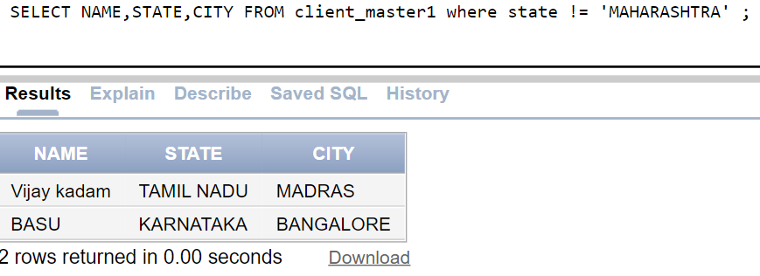Select name ,city,state from client_master1 where state!=‘MAHARASHTRA’;

23).list the employess who are not working for deptno 10 and 20

* 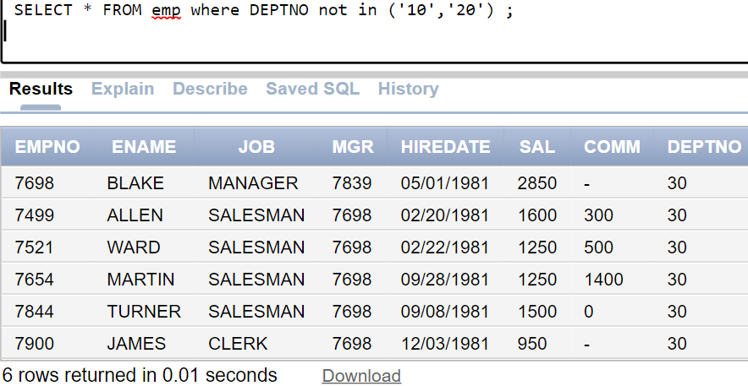Select * from emp where deptno!=10 and deptno!=20;